# W08: Instructor Notes

## Overview

This week is a follow on to Week 03 Methodology & 04 Techniques.

Focus of the week will be Regression Testing.

## Objectives

By the end of the week, each student will be able to:

* Differentiate Testing Level (Unit, Integration, Regression, System)
* Develop a Regression Plan

## Before the Week Begins (Prepare)

### Preparation:

* Have installed Visual Studio Community with Python and Selenium plug in Installed
* Understand how TiddlyWiki works and access tags within the framework.
* Post Annoucement.
* Coordinate with TA.
  + Discuss struggling students and make plans to support and mentor.
  + Discuss W07 grading expectations.

### Partnership/Group work:

* The student will be working in groups to modify automated tests using the TiddlyWiki [Dr. Mobile](https://byui-cse.github.io/cse270-course/Labs/DrMobil.html) application.
* Check Canvas “groups” to verify that all students are enrolled in a group.

## During the Week (Teach)

### Labs:

* Dr. Mobile is to help Emergency Medical Personal with rescue and aid in times of disaster. There is a general workflow that any medical personal does to complete their task to stabilize a person.
* Dr. Mobile is a similuated via Tiddlywiki. This simulation is going to be tested via Selenium automated test code.
* Because there are minor python prerequisites for coding for this class, Students will be modifying the code.

## Looking Ahead

Next week's announcements:

* Please create and post your Announcement for W09 by Friday of this week.

# Prepare

## Overview

Most testing will fall into different stages of software lifecycles. This week is a follow to Week 03 & 04. We will explore which types of tests (04) for each phase of the lifecycle (03).

This week we are expanding from Test Case, which deals with Unit level, to the System and Integration level of the Software Development lifecycle phases. The focus is on Regression Tests. There is not enough time to test every possible variable, code path, and how a user could use a complex software system. A Regression Test is a small subset of all the possible tests. They say, "make it idiot-proof, and there is always a smarter idiot." Regression tests are more than the happy path (options that don't produce any errors); they also test performance, robustness, and fault tolerance. The majority of Regression tests' uses are in Software Maintenance and tests derived from the Acceptance Tests or Coverage Tests. From the 1st Iteration, a regression plan should be in place to prevent error creeping into the baseline, and this holds for from Spiral to Test Driven Development to Agile methodologies.

## Objectives

By the end of the week, each student will be able to:

* Differentiate Testing Level (Unit, Integration, Regression, System)
* Develop a Regression Plan

## Preparation Material

To be prepared for this module's activities, please read the following and be prepared to start or complete activities for Teach One Another and Prove assignments.

### Reading

* [See Reading.](https://webmailbyui-my.sharepoint.com/personal/wac3_byui_edu/Documents/GitHub/cse270-course/Reading/Reading.html)

As you read, keep the following questions in mind:

* Which testing techniques are used for Regression Testing (See Module 4)?
* What is happy path testing?
  + Is it just the non-error path?
* Is it possible to create enough tests to cover all code created?
  + There are several strategies in writing code to ensure complete code coverage. Research and provide a summary of your findings.
  + What are the risks?
* How do you migrate a manual test into an automated test?

# Lab 08 - Executing Regression Test

## Overview

[Dr. Mobile](https://byui-cse.github.io/cse270-course/Labs/DrMobil.html) is to help Emergency Medical Personal with rescue and aid in times of disaster. There is a general workflow that any medical personal does to complete their task to stabilize a person.

As you read about the workflow, imagine the following natural disasters that might happen

* Hurricane
* Earthquake
* Blizzard
* Avalanche
* Forest Fire
* Airplane Crash
* Traffic Accident
* Flooding

### Workflow

Each activity in the workflows allow the EMP to accomplish some task with the Dr. Mobile Application:

* Patient Identification
  + Collect found patient's information. Typically, this information is a one-time collection.
    - Name.
    - Fingerprints.
    - Location.
    - Race,
    - Weight/Body Mass.
    - Height.
* Diagnose
  + o Once some quick information is collected, continue collecting finer details about the patient's condition.
    - Temperature - is the patient running a fever, infectious, or showing signs of shock.
    - Heartbeat - is the patient's heartbeat high.
    - Blood pressure - determine if the patient has high, low, or normal blood pressure.
    - Breathing - determine for substances, CO2 content.
    - Oxygen level - does the patient have low oxygen levels.
    - Skin moisture - slightly different than normal Temperature, as a patient could be in shock and sweating but not having a fever.
    - Eye exam - could tell about concussion.
  + Additional detailed scans:
    - Bone - portable X-ray could check for bone damage.
    - Neuropathy/Electrical – evaluation of nerve, brain, and respiratory systems.
    - Muscle & vain - scan for Muscle tears, bruising and internal bleeding.
    - Skin - checking for burns, veins, and radiation.
* Treat
  + Disinfect - UV disinfection equipment, wounds.
  + Treatment method.
  + Advice from home base.
* Monitor Patient
  + After the patient is
    - IV Monitoring.
    - External Wristband.
      * Heart.
      * O2.
      * Temperature.
      * Blood pressure.
      * Skin moisture.
  + Device to Device redundancy.
    - § Check for similar events in the same location.
    - Bi-location of scans.
* Order Supplies
  + Collection of supplies on hand.
  + Monitory supplies in use.
  + Resource frequency checking.
  + Restocking

## Assignment

You will create two manual regression tests for two different situations that will test capabilities. The following is one regression test that would test the workflow of [Dr. Mobile](https://byui-cse.github.io/cse270-course/Labs/DrMobil.html). Using the [Dr. Mobile](https://byui-cse.github.io/cse270-course/Labs/DrMobil.html) App simulator as reference to answer the following questions. You can either use the happy path, where everything works, create a problem and point out where the system might fail.

Start with a situation, use the workflow (search, identify, diagnose, treat, monitor, order supplies) to identify the steps.

Start with this situation, Avalanche:

### SITUATION – 1st Post

* **When**: During Christmas break in Vail, CO, the area has been experiencing a warm and cooling spell with a significant snow amount. On December 27th, a major avalanche occurred, and a team of 3 EMP was dispatch as first responders, each equipped with [Dr. Mobile](https://byui-cse.github.io/cse270-course/Labs/DrMobil.html).

### Patient Identification

* + **Who**: What will be done to id the patient?
  + **Assumption:**
    - **EMP has already logged in**
    - **EMP is at the DrMobileHome page, and click on the PatientMenu**
  + **Steps**:
    - **A: EMP clicks on AddPatient tab**
    - R: Add Patient options is display on menu
    - A: EMP enters patient id, “Patient C” in “Enter New Id” text field, and clicks Add Patient
    - R: Patient Name is add to the list of “Current Patients” right after Patient B.
    - R: Two additional fields “Enter First Name” and “Enter Description” appear.
    - A: EMP enters patient name “John Smith” in “Enter First Name”.
    - A: EMP enters patient description “Found in snow bank” in “Enter Description”
    - A: EMP click Done.
    - V: Fields disappear

### Diagnose

* + **What**: What is the problem with the patient?

### Treat

* + **How**: How will the patient be stabilized?

### Monitor

* + **How:** How will the patient be monitored until and during transport?

### Order Supplies

* + What supplies are now needed? What is in need now? What is needed later?

Situation – 2nd Post

Now create your own situation, and write tests according.

## Fault Tolerance

Remember, the system doesn't always work the way it is supposed to. Read a classmate's situation, identify a fault, and explain how the system should react. Also include what other situations would a classmate's regression test validate?

## Submission

Submit two posts, one about the Avalanche and the other of your scenario.

Submit reply to classmate's situation.

## Rubric

Use the following rubric to help understand the expectation.

|  |  |  |  |  |  |
| --- | --- | --- | --- | --- | --- |
|  | **Exceptional 100%** | **Good 90%** | **Acceptable 70%** | **Developing 50%** | **Missing 0%** |
| **1st Post 35%** | Include Supplies | Summary include Treat and Monitor | Summary includes Patient Id and Diagnose | The summary scenario | No original post |
| **2nd Post 35%** | Include Supplies | Summary include Treat and Monitor | Summary includes Patient Id and Diagnose | The summary scenario | No original post |
| **Fault Tolerance (Reply) 20%** | Reply include another scenario. | The reply includes system reaction | The reply is on the subject and has identified fault | The reply does not reflect the scenario or doesn't mention fault tolerance | No Reply |
| **Professionalism 10%** | The paper is easy to read and communicated. | Properly cited, there are no grammar or spelling errors, and the writing style is "professional." | Found an instance of a spelling error, grammar error, incomplete citation, overly verbose wording, poor formatting, or poor writing. | A citation is missing where one is needed (plagiarism alert!). | Gross spelling/grammar errors or other aspects of the writing that make the paper difficult to read. |

# Prove M08: Regression Testing

## Overview

There is not enough time to test every possible variable, code path, and how a user could use a complex software system.  A Regression Test is a small subset of all the possible tests.  They say, make it idiot-proof, and there is always a smarter idiot. Regression tests are more than the happy path (options that don't produce any errors); they also test performance, robustness, and fault tolerance.

## Backstory

This is a simplified and automated version of the Lab.

### Overview of the Dr. Mobile Simulator.

The similar use a TiddlyWiki, web page. The TiddlyWiki is architectural structure is broken down in by div tags. The following diagram shows the structure breakdown from a HTML documents down to where we will be testing the HTML content (dark green).

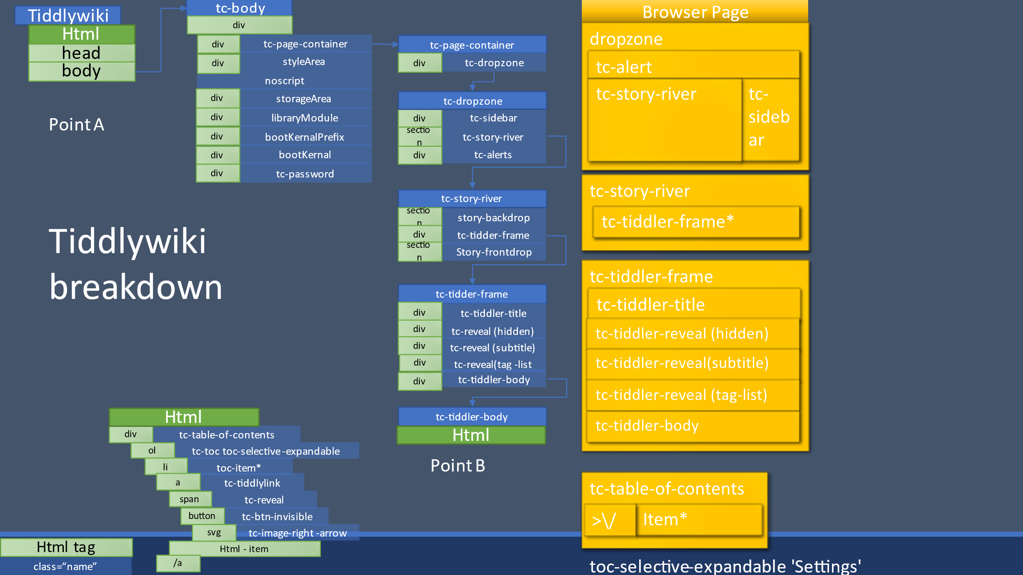

For the most part we are conserted from Point A to Point B.

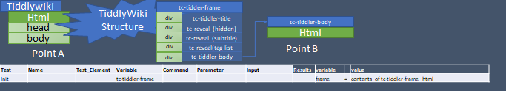

From Point B, Dr. Mobile is built. Dr. Mobile simulator has four functions: _H_(Home), Patients, Communicate, and Settings.

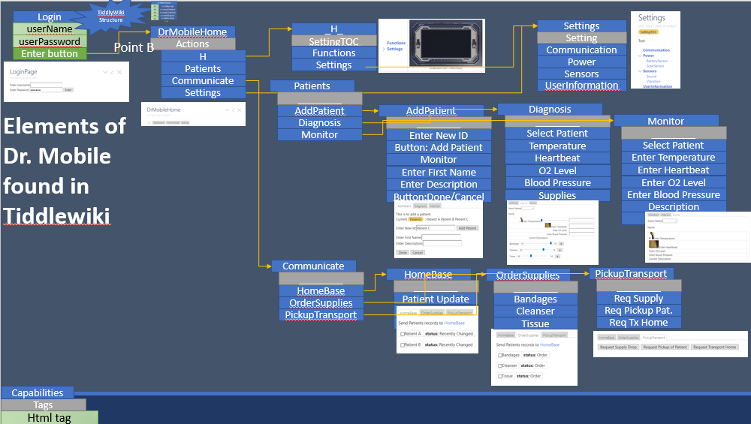

* From the _H_ tab, a User can see the Functions(not implemented) and Settings.
* From the Patients tab, a User can AddPatient, Diagnosis, or Monitor
* From the Communicate tab, a User can send patient infomation to HomeBase, OrderSupplies, or request PickupTransport.

### Overview of the Test Code.

The test code uses a list of elements to interate through unit test steps. The list’s elements are name, test_element, variable, command, parameter, input. As summary follows, but the code contain the details.

* Name - text field describing the unique step.
* Test_Element – Ids the type of command as step, results, or verify.
* Variable – name of a variable that will store the results in the Results dictionary/db.
* **Command** – a set of commands that will pull information out of the input variable, based on the parameter
  + **Step Commands**
    - ***attribute*** – uses parameter to find an attribute of the input input
    - ***className*** – uses parameter as the classname in input, to find the html tag set with classname attribute
    - ***tagname*** – uses parameter as the html tag to search input for html tags names. (usually returns an list)
    - ***getListItem*** - will return an item in the list (input), based on the index (parameter, zero index)
    - ***click*** - - if the input is list of buttons, it will activate the button, with index (parameter)
    - ***click_single*** - if the input is a single button, it will activate the button.
    - ***sendkeys*** - if the input is a text field, it will send the keys found in parameter to the text form element.
  + ***Results/Verify***
    - equal – compares command input with other parameter input
    - exists – determines if input variable content exists
    - compare – checks to see if parameter text is found within input results.
* **Parameter** – 2nd input to the command to know what to do.
* **Input** – provides the html code or values based on previous Variable names

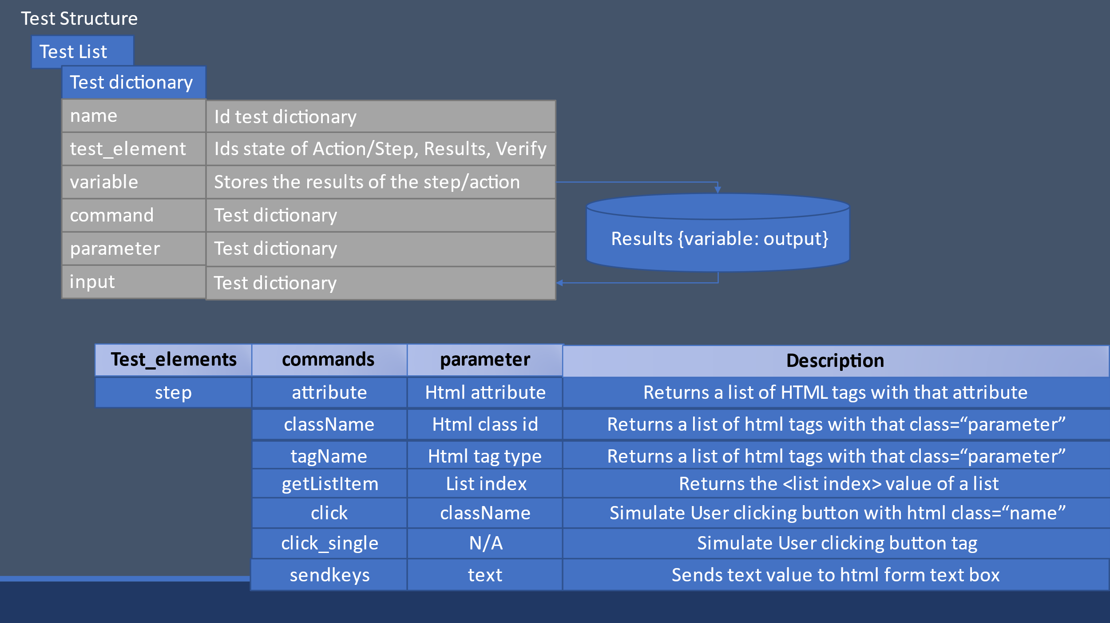

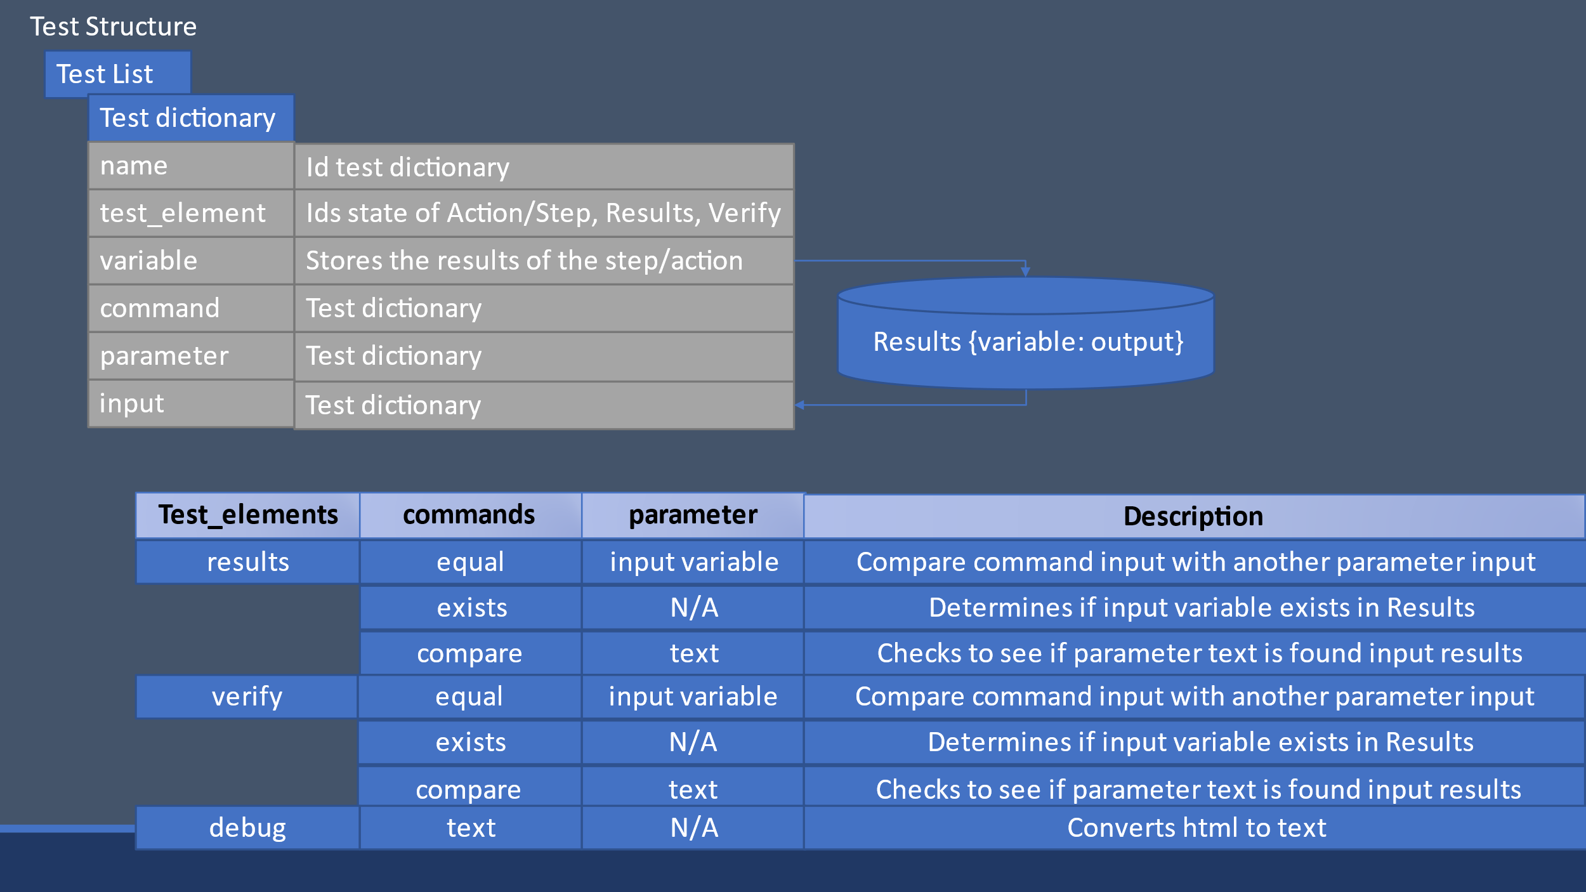

## Instruction

You will be modifying [automated test code](https://webmailbyui-my.sharepoint.com/personal/wac3_byui_edu/Documents/GitHub/cse270-course/Labs/CSE270M08TeachLabDrMobilSeleniumCode.py) using Selenium and the [Dr. Mobile](https://byui-cse.github.io/cse270-course/Labs/DrMobil.html) Simulator webpage to create your tests.

Copy the tests code to a project. Read through the code, and identify the four tests associated with Patient Information, Diagnose, Monitor Patient, and Order Supplies.

Each test addresses a workflow, similar to what you did in the Lab. You will need to modify the code for Diagnose, Monitor Patient and Order Supplies. Use Patient Identification as a example.

In a word documents, create four sections, one for each Step. This will be your code documentation. Make sure your name is on it.

1. Login: Tests the login capability

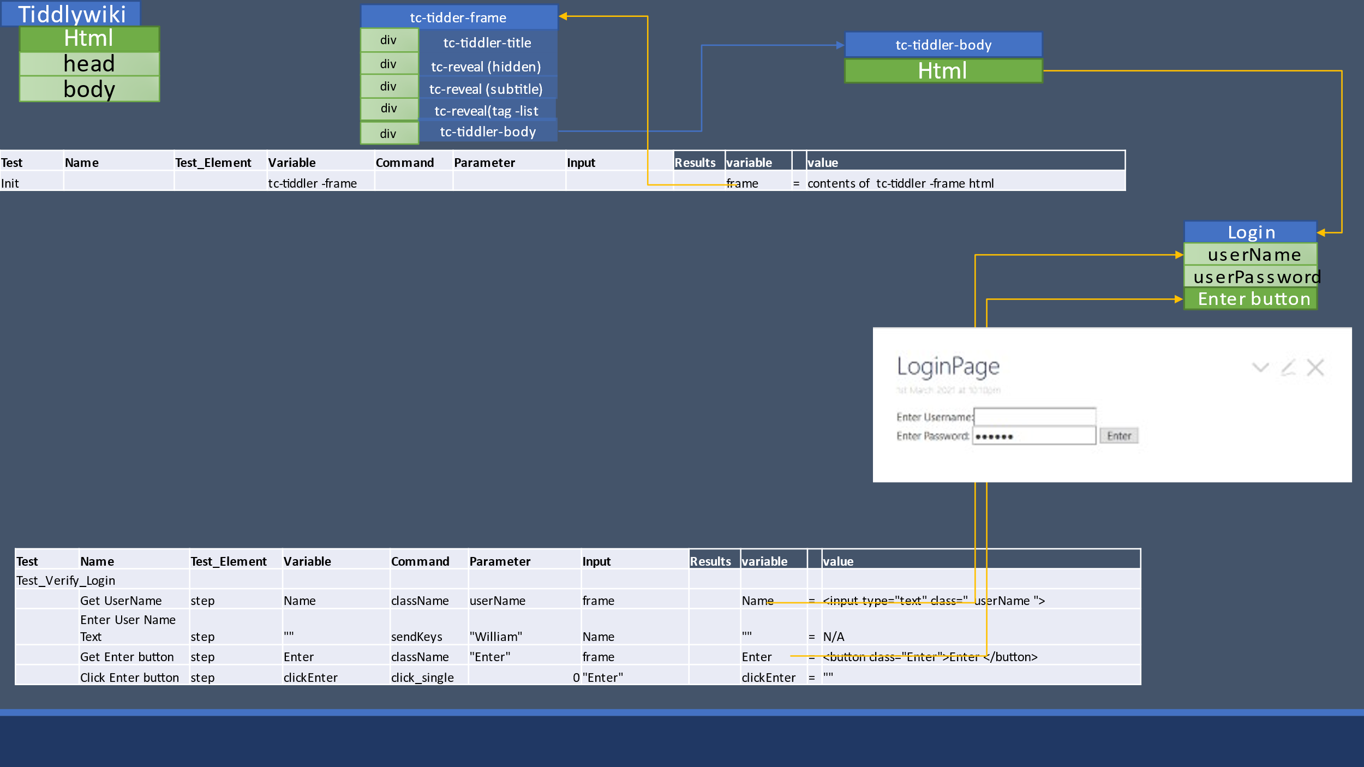

1. Verify Home Page

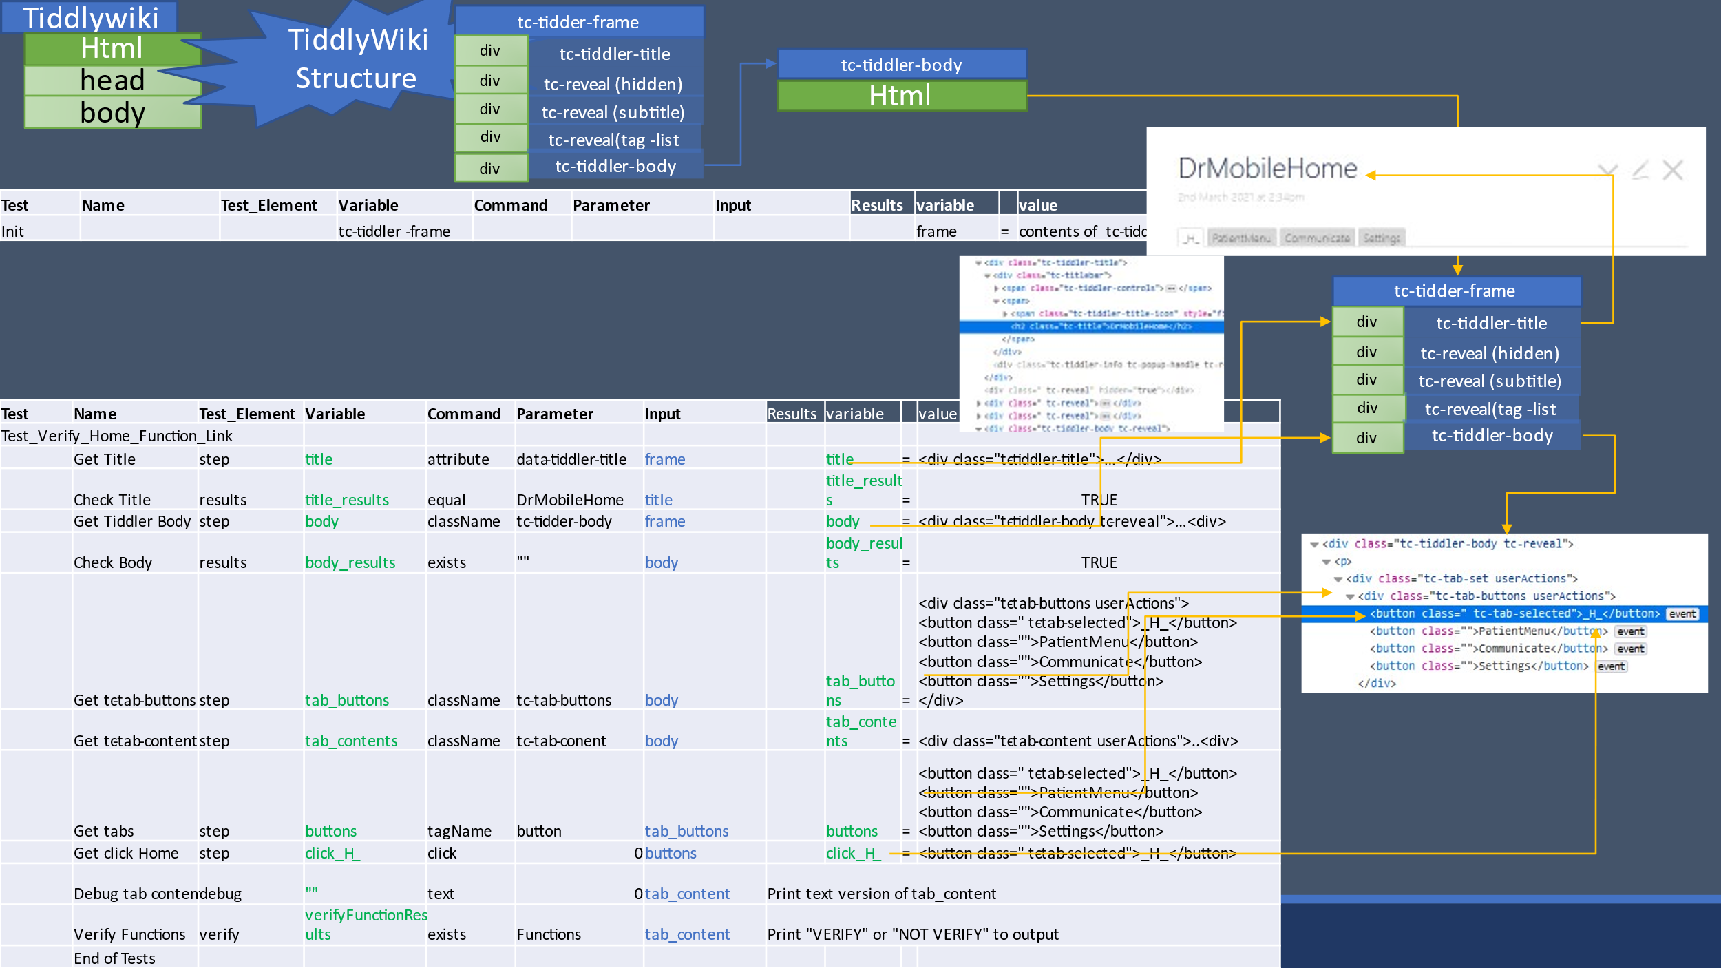

1. Patient Identification: Try to get the simulator to add a patient, with a new id, "Add Patient" button clicked, Name and Description filled in, and "Done" button clicked.
   1. 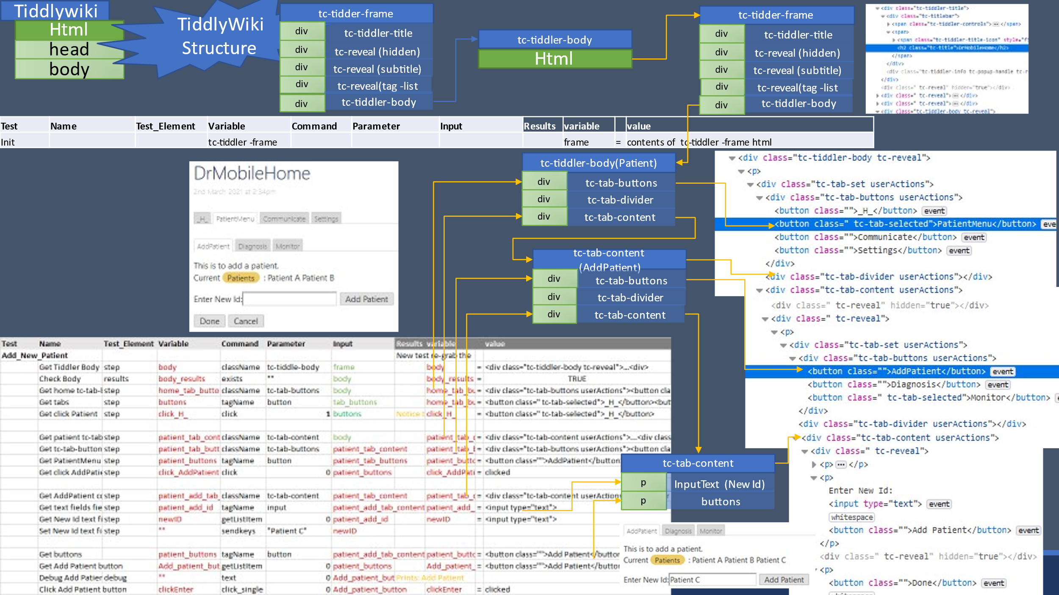The code is already done for you. Look over the code and walk through it using an HTML inspector from your browser.
   2. Code works on Dr. Mobile to add "Patient C"
   3. In the code documentation of the assignment indicated that you got the code downloaded and it worked. Provide a screen shot of the output terminal screen. Find in the output, the line the specifies that this test worked, and include it in the comment.
2. Diagnose: Have the simulator select a patient
   1. 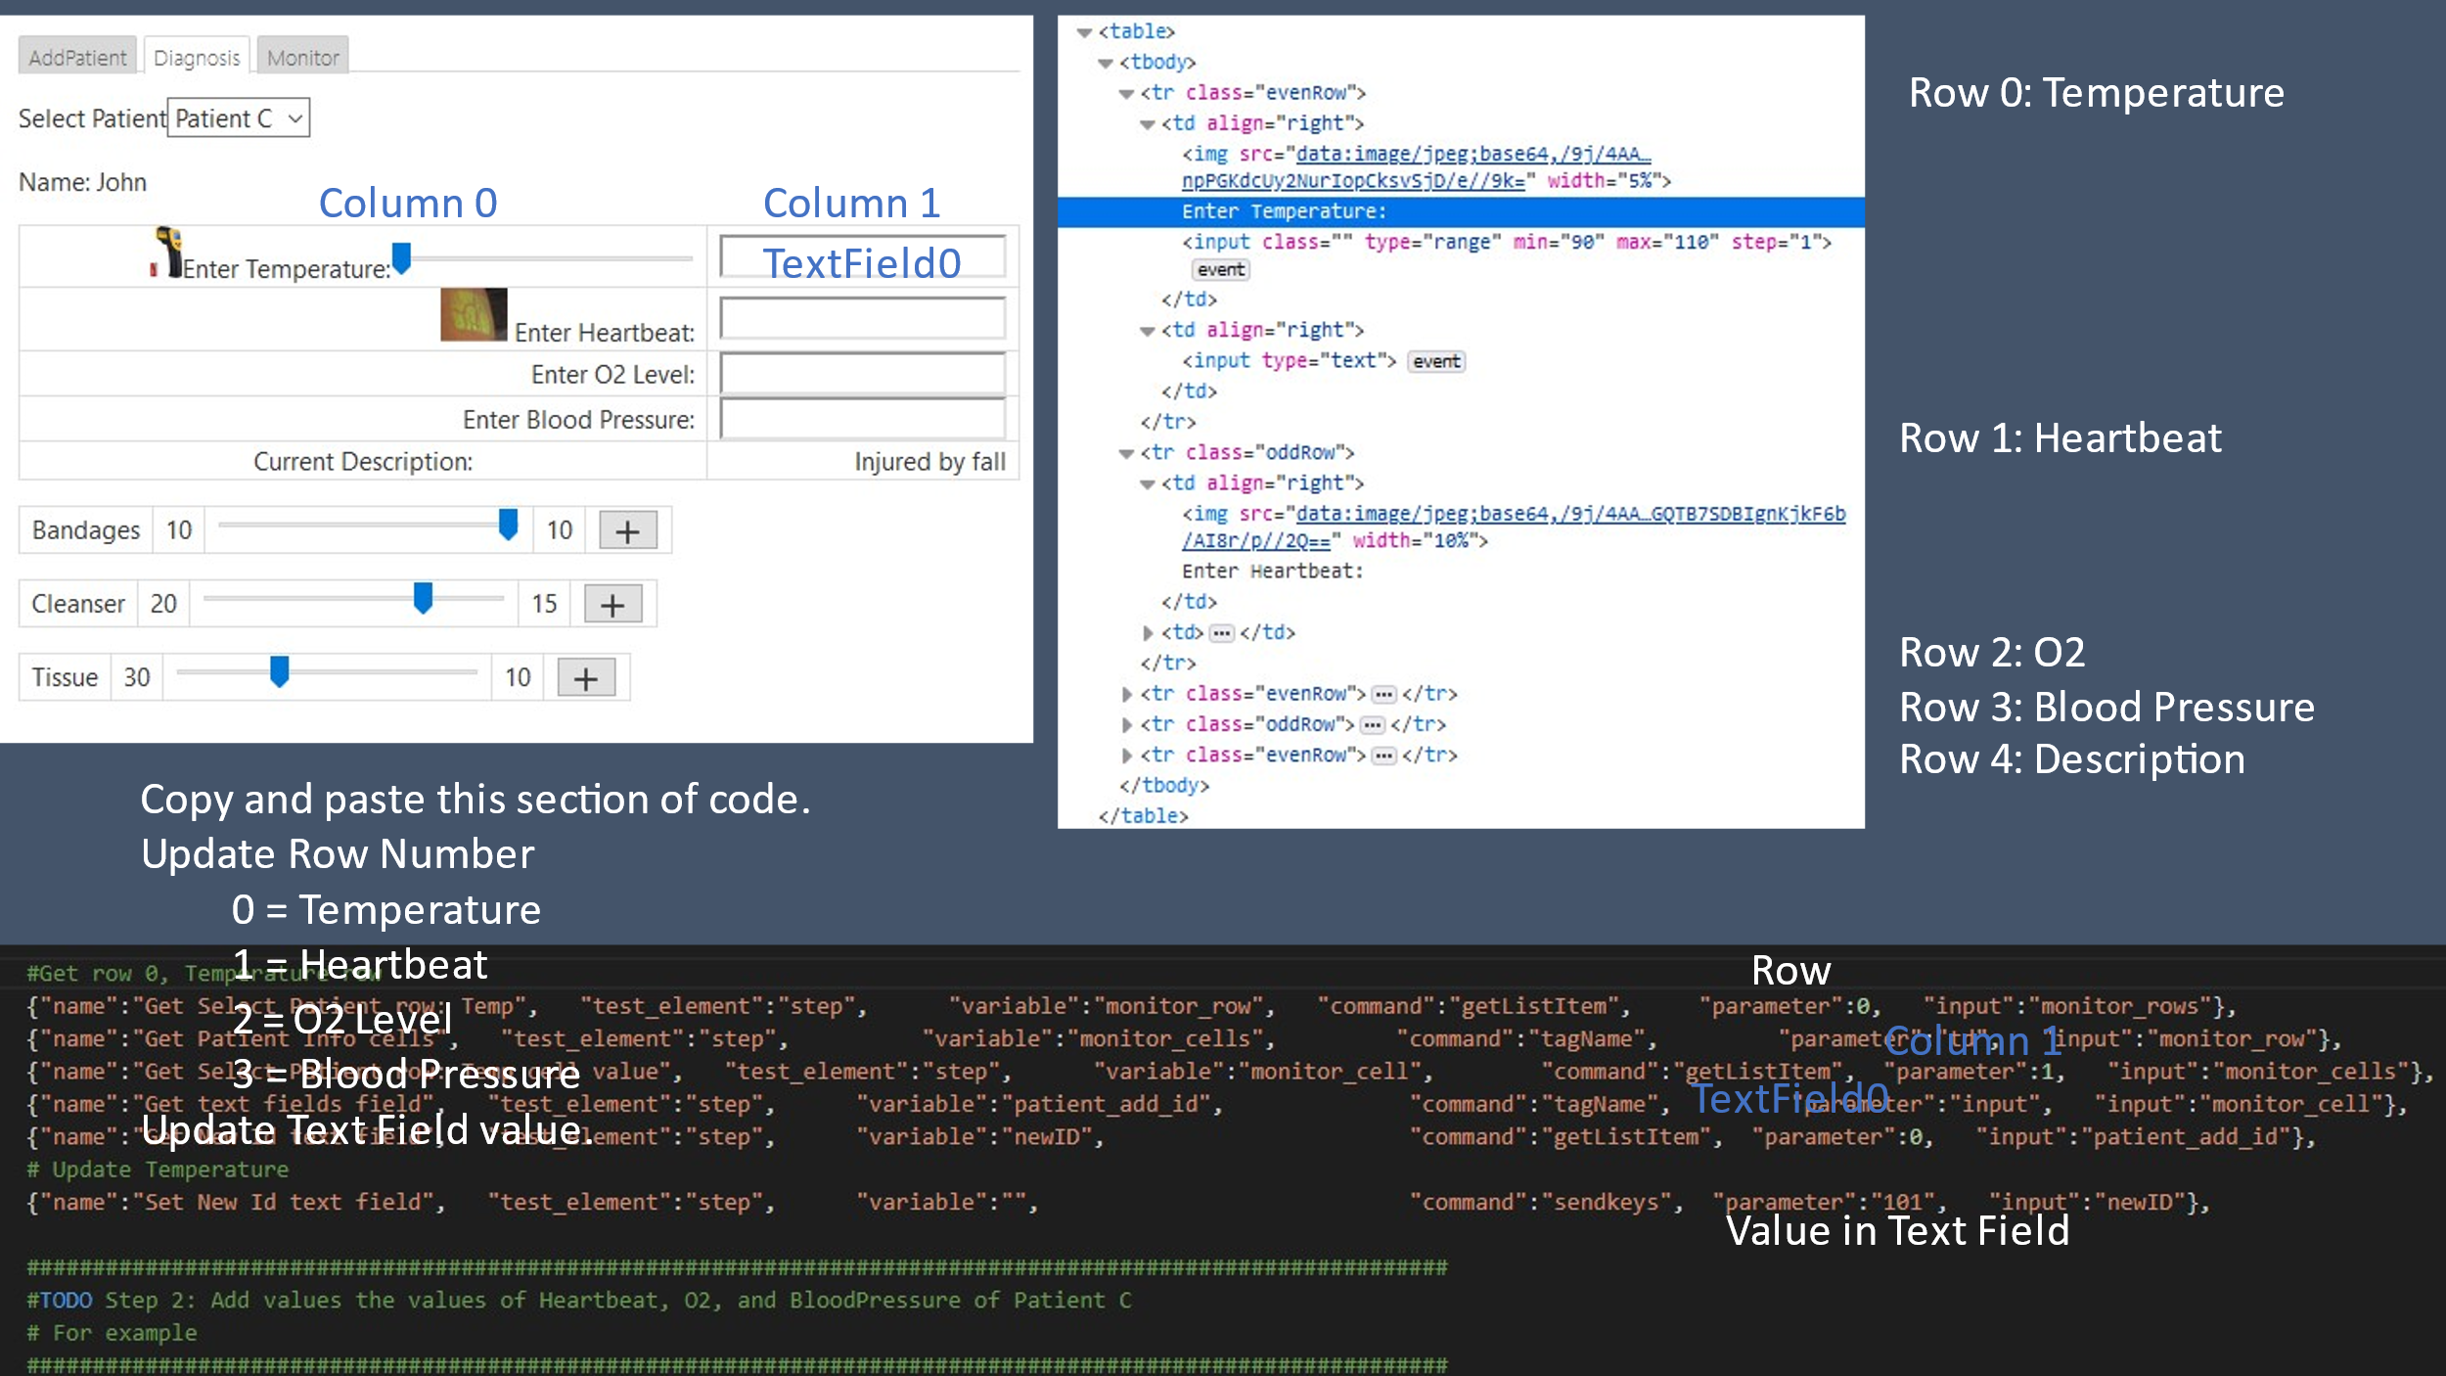Add code that will enter Temperature, Heartbeat, O2, and blood pressure to Patient C. See TODO section. Code is provided to start you on your way to Enter Temperature.
      1. Temperature = 101
      2. Heartbeat = 96
      3. O2 = 95%
      4. Blood Pressure = 120/75
   2. In the code documentation of the assignment, indicate that you see the output of this automated test, by providing the last line of the Temperature Test from the output. Once other Three are modified, inidicate there last line in the output.
3. Monitor Patient: Have the simulator verify that the Blood Pressure is 80/120
   1. 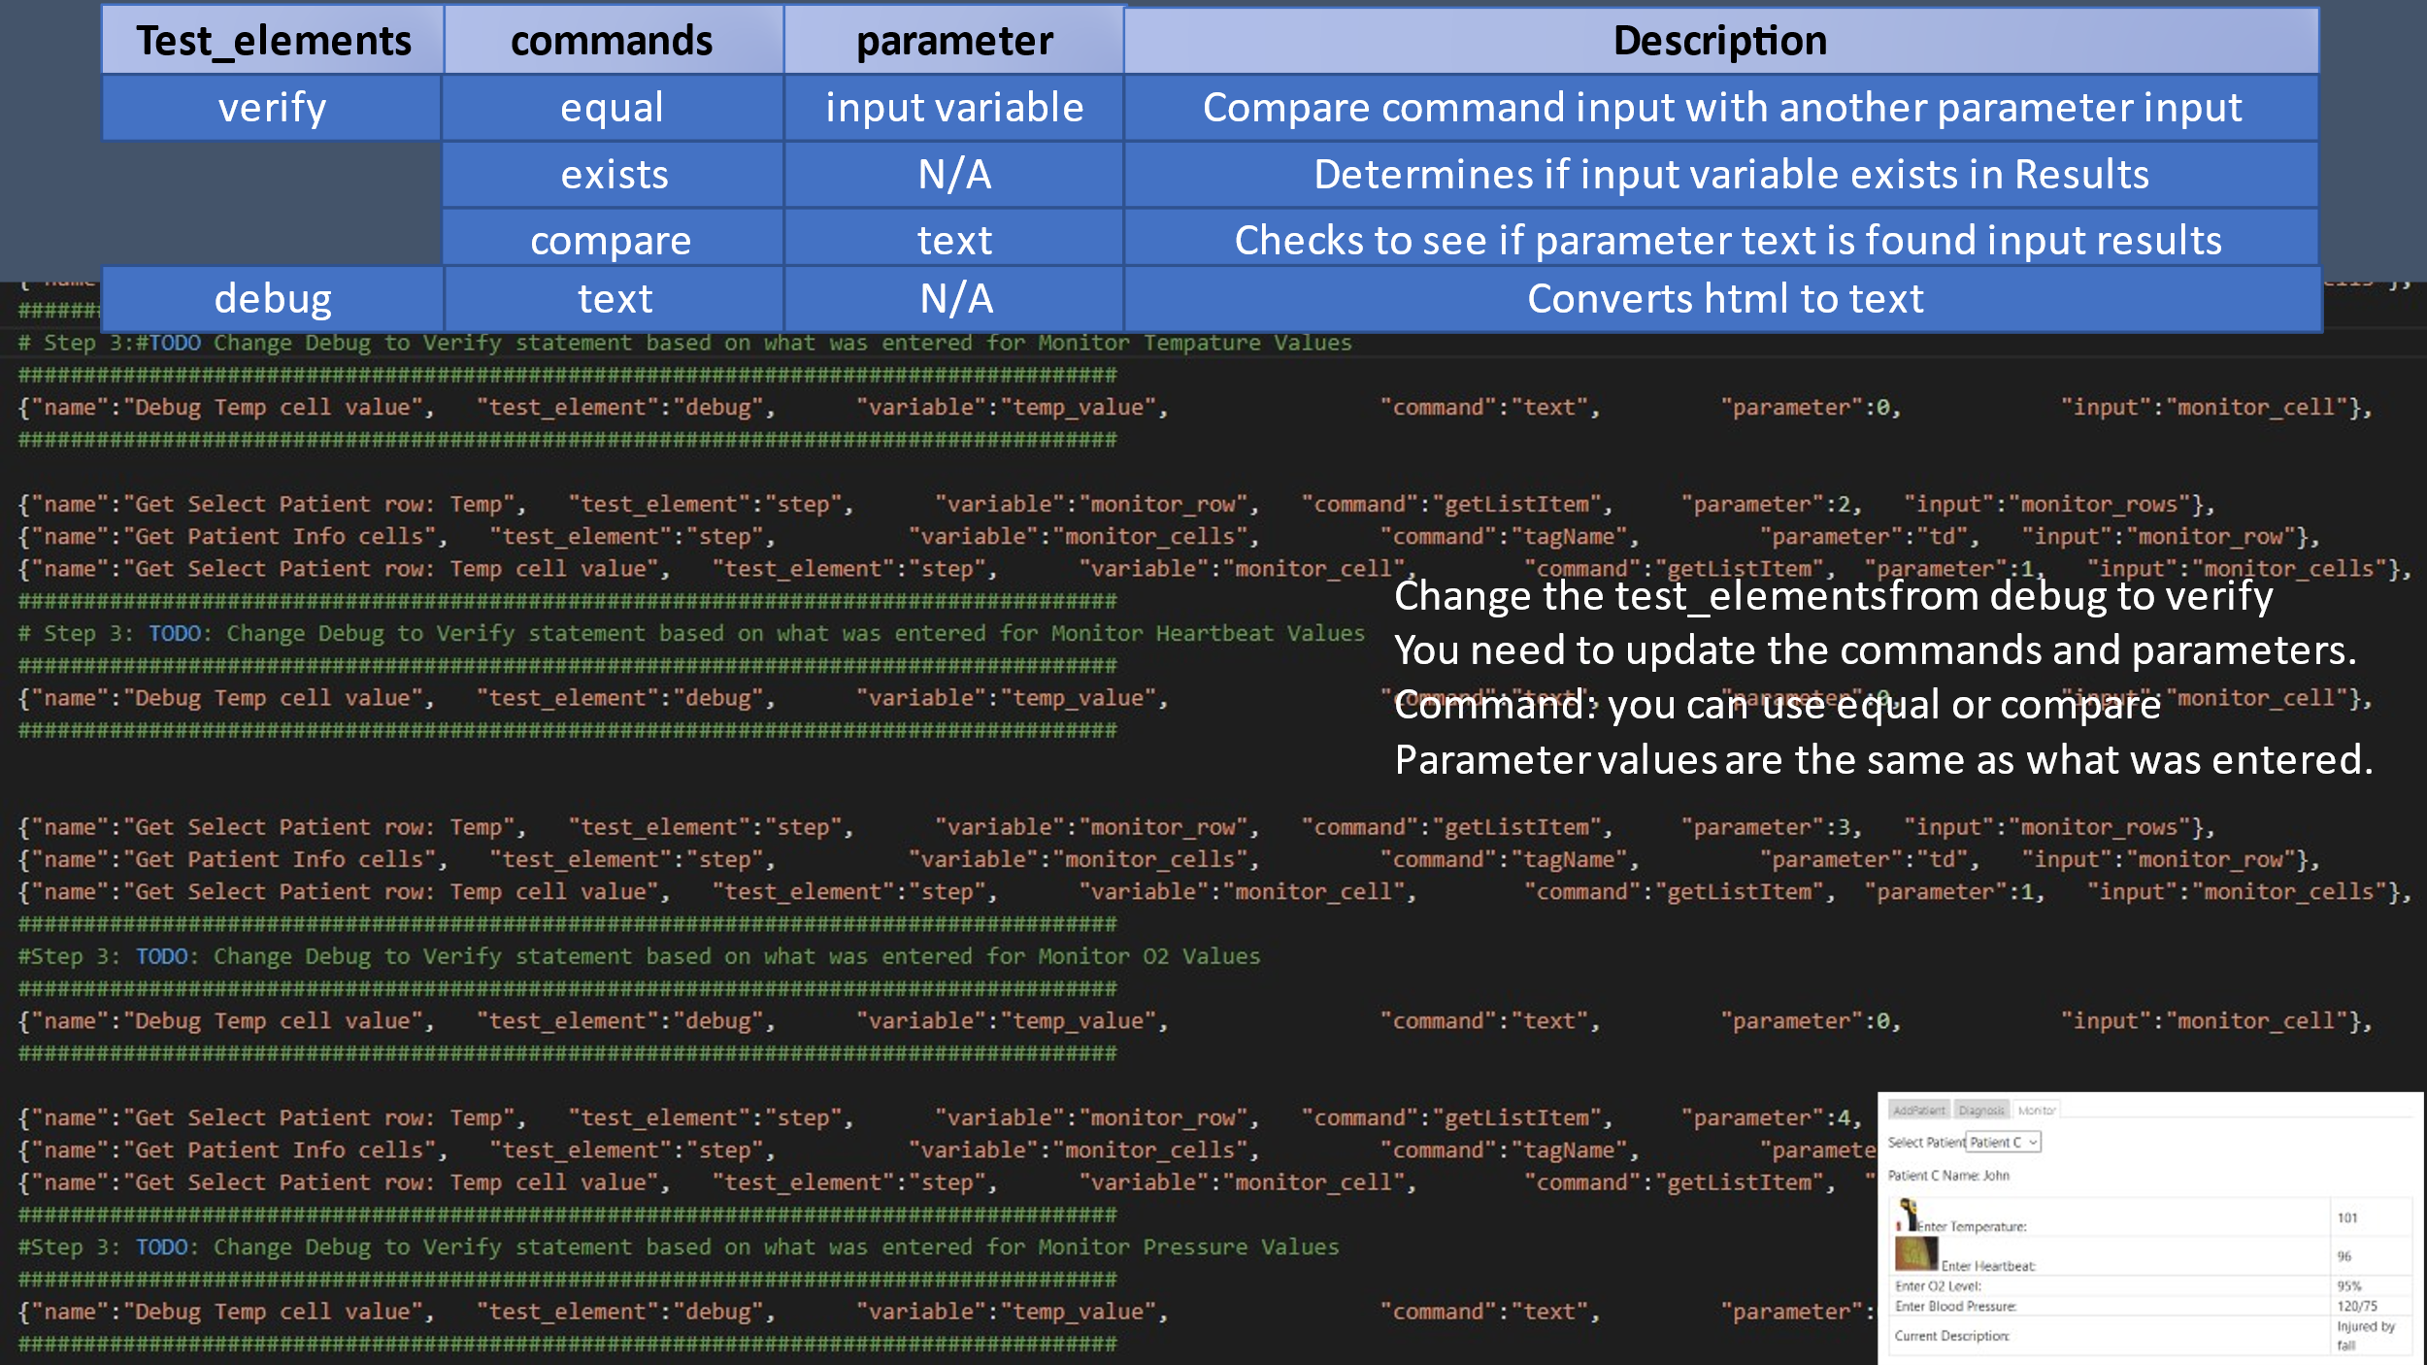You will need to Change the Debug commands to Verify commands later in Test_Verify_Diagonse().
   2. In the code documentation, copy the four lines that you changed.
4. Order Supplies: Have the simulator verify that it lists Bandages, Cleanser, and Tissue
   1. 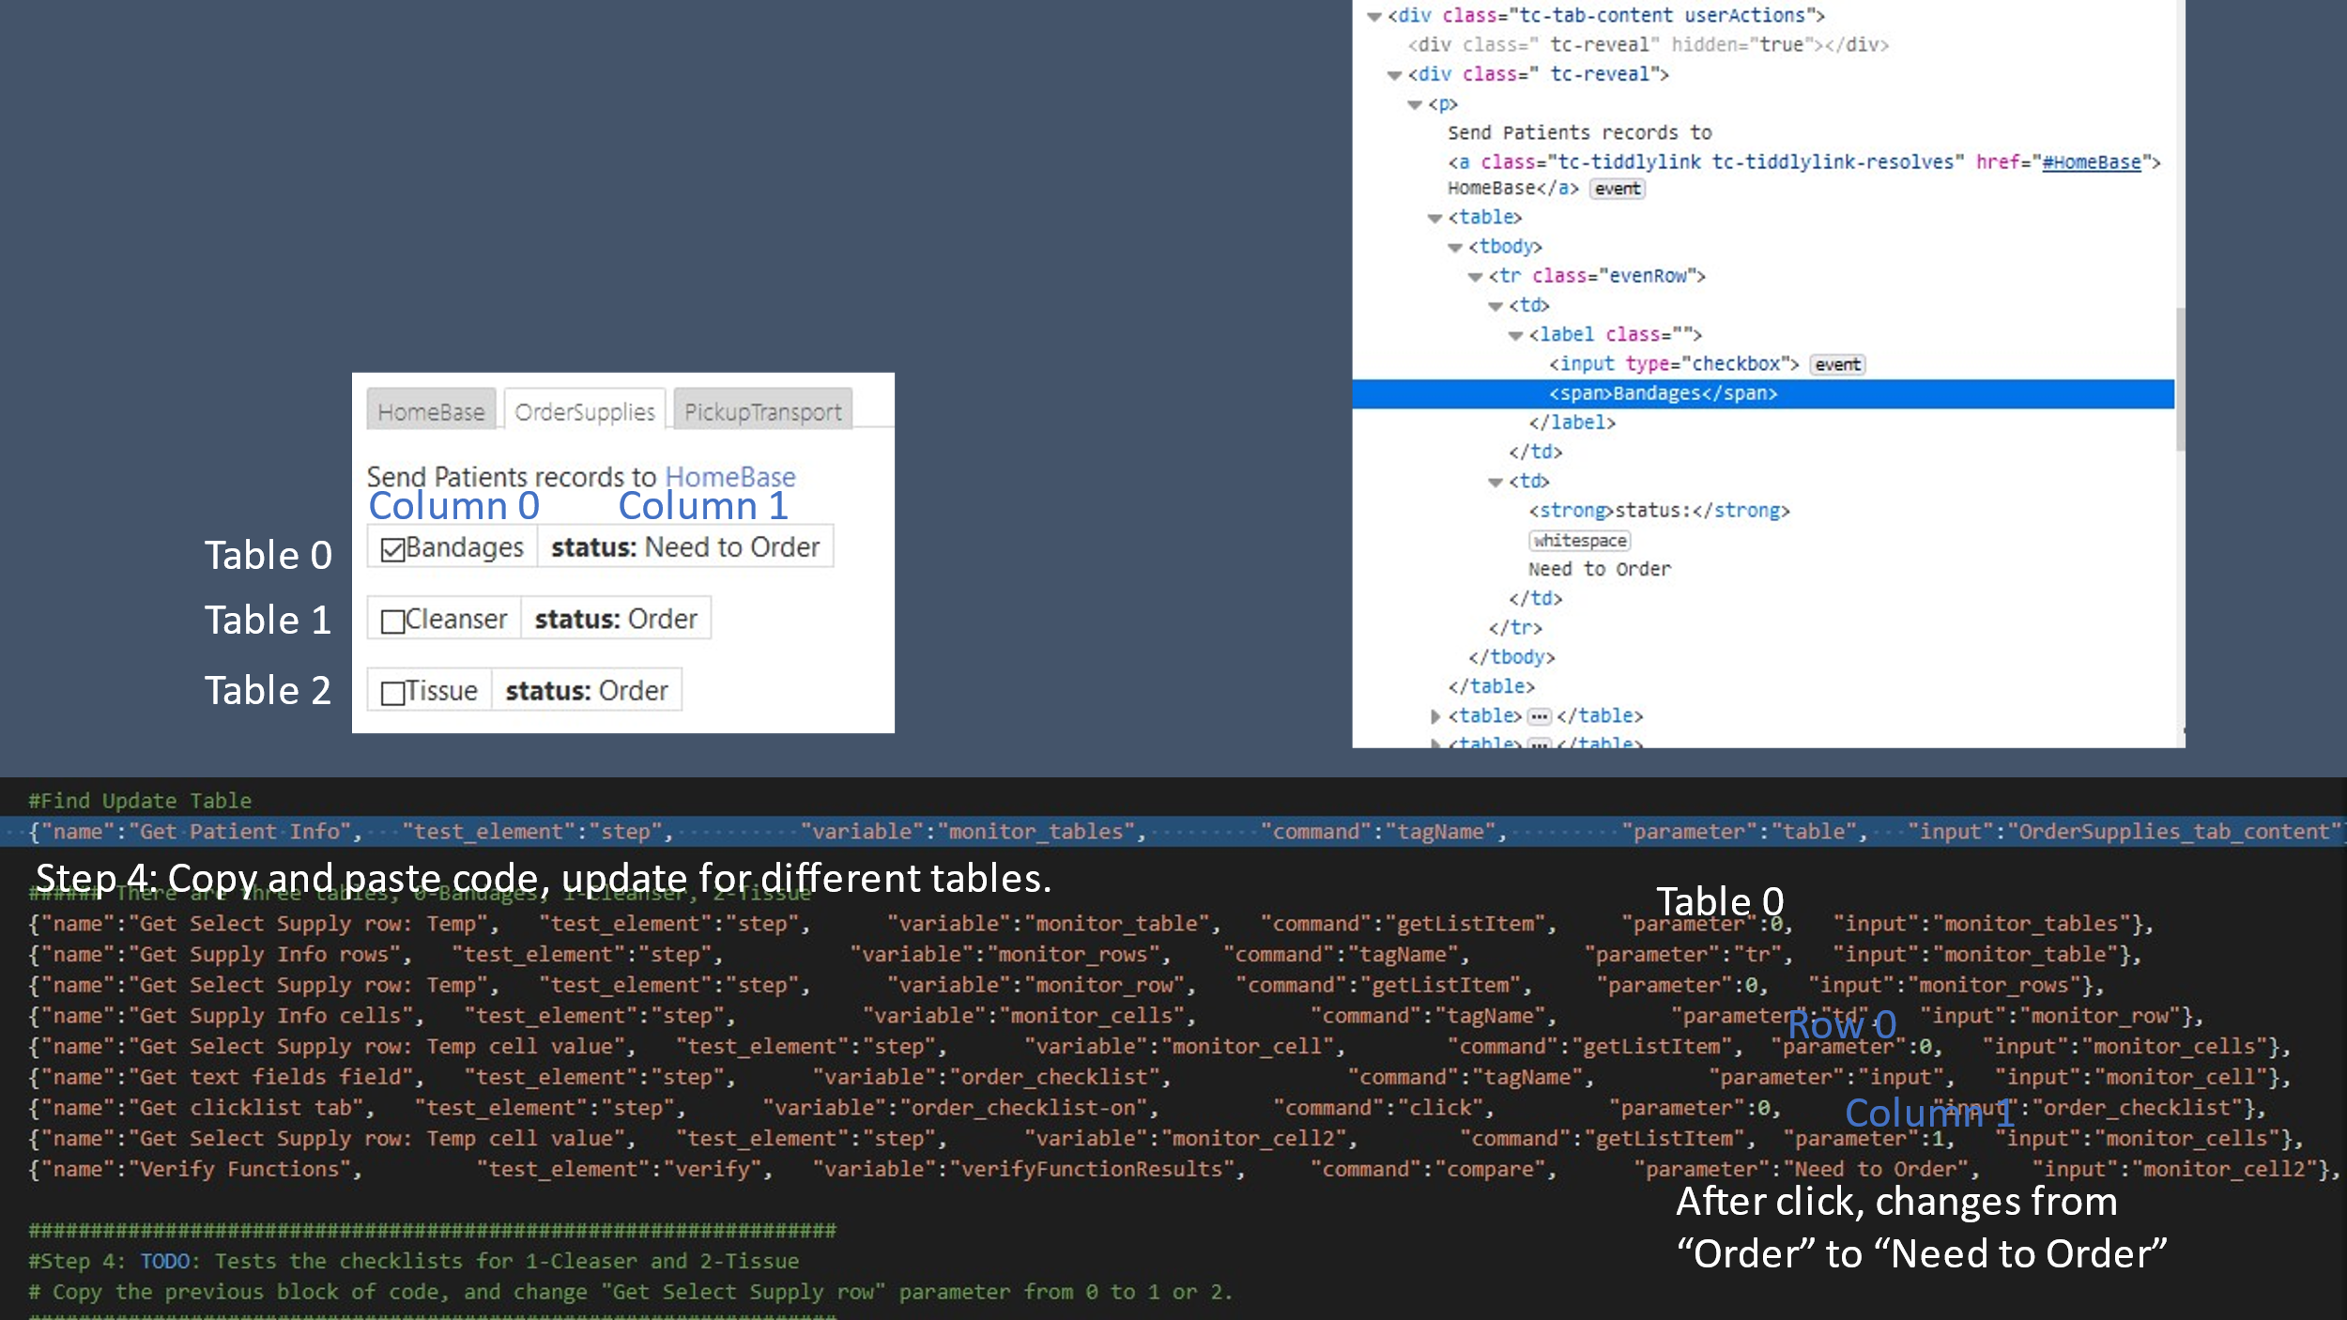Review the code to check the check-box for Bandages.
   2. Add code to handle activating Cleanser and Tissue
   3. In the code documentation, copy in the code that you created for Cleanser and Tissue.

## Submission

Make sure that you upload a copy of your python code and your code documentation to iLearn..

## Rubric

Use the following rubric to help understand the expectation.

|  |  |  |  |  |  |
| --- | --- | --- | --- | --- | --- |
|  | **Exceptional 100%** | **Good 90%** | **Acceptable 70%** | **Developing 50%** | **Missing 0%** |
| **Patient Identification 10%** | Comment has log out for this test as successful | Code ran successfully. | Run the code. | Downloaded the code | No answers to questions |
| **Diagnose Tests 50%** | Added Blood Pressure, and last line of test from output | Added O2, and last line of test from output | Added Heartbeat, and last line of test from output | Last line of the test for Temperature. | No answers to questions |
| **Monitor Tests 10%** | Change Blood Pressure Debug to Verify | Change O2 Debug to Verify. | Change Heartbeat Debug to Verify | Change Temperature Debug to Verify | No answers to questions |
| **Order Supplies Tests 20%** | Added comments to the code. | Implemented coded for testing of ordering the Tissue | Implemented code for ordering the Cleanser | Reviewed the code for Bandages | No answers to questions |
| **Professionalism 10%** | Make it your own | Properly cited, there are no grammar or spelling errors, and the writing style is "professional." | |  | | --- | | Found an instance of a spelling error, grammar error, incomplete citation, overly verbose wording, poor formatting, or poor writing. | | A citation is missing where one is needed (plagiarism alert!). | Gross spelling/grammar errors or other aspects of the writing that make the paper difficult to read. |